2017 TTC Store – Frequently Asked Questions

Last Updated: Monday April 24, 2017

Question | Answer
I have the old TTC kit. Do I have to purchase a new one? | You don’t have to purchase anything new if you don’t want to!  We love the ‘classic’ TTC kits!  Please continue to wear them to races and in training events.
Why can’t I see the finished product before I purchase it? | This is the TTC’s second season with the new kit design.  Due to the custom nature of the orders, all sales are final.  As such, if you are not comfortable purchasing until you can see a final product we recommend you come to one of our kit fit socials to see samples.
Why does it take so long to receive the items I have purchased? | Similar to other clubs, the TTC will now place bulk orders at regular intervals throughout the year. This allows for the club to provide a larger offering, since we no longer carry inventory.  Orders take approximately 5 weeks from the order close date to arrive. You are encouraged to refer to the Order Calendar for important dates and cutoff times.  https://www.torontotriathlonclub.org/TTC-Web-Store-Info
I would like to purchase a casual t-shirt, will that be available? | Casual shirts are not part of the ongoing club wear inventory.  The TTC may order more casual t-shirts in 2017, but it has not been finalized at this time. If you are interested in a casual t-shirt please email marketing@torontotriathlonclub.org to express your interest.
Will you make new/different items available in future years? | Yes, the plan is to expand the product offering slowly with a few new products each year. 2017 we will offer: arm warmers (lite & fleece), running singlets for men & women and running shorts for women.  Send your suggestions to marketing@torontotriathlonclub.org
I want to order a TTC water bottle but don’t want to pay $12 shipping! How do I do that? | The water bottles are great!  We added them for sale on the site assuming members may want to ‘add on’ to their gear order. If you wish to purchase a water bottle on it’s own, you may also do so in person at club socials and/or special events. Please feel free to email marketing@torontotriathlonclub.org to inquire or order in advance.
How does TTC set the prices for the items being sold? | Due to volume orders, the TTC receives the best prices that Champion System can offer.  The TTC Club Wear prices you pay represent only the recovery cost to the Club. No Profits or margins have been built in.  The prices include: merchandise cost, sales taxes paid by the club, admin costs (order cost, payment processing), and design allocation.

Why does the “swim-bike-run” icons on the shorts run from bottom to top of the left leg? | It is standard for cycling/tri shorts to be designed to be read while on the bike. Think about how the logo is read when you have your left leg in a 90 degree position. It will read swim, bike, run from left to right.  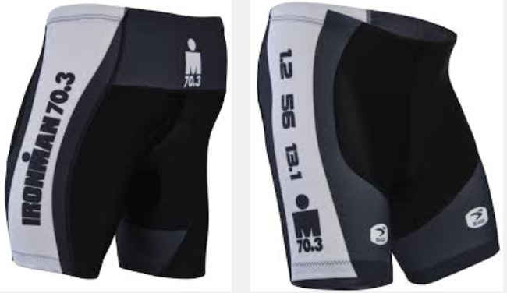
(new)  I understand Champion System allows for customization on their clothing. Why is this not available for TTC items? | At this time, the club decided not to offer customized clothing in order to keep the order process simple.  This decision may be re-evaluated in future years.
What’s new for 2017? | This year we will have Lycra Arm Warmers, Fleece Arm Warmers, Men’s Running Singlet, Women’s Running Singlet and Women’s Running Shorts.
What has changed for 2017? | All of last year’s amazing Triathlon gear is the same. Champion has taken their customer’s feedback and made changes to the cycling line and the Bella line. This did affect our kits. Whereas last year, we had 5 different jerseys, these have been combined into 3 different styles that we now offer. All items are available in men’s and women’s sizing and design.

Where can I get more information if my question is not listed here? | Email marketing@torontotriathlonclub.org  We will attempt to respond within 24 hours.

